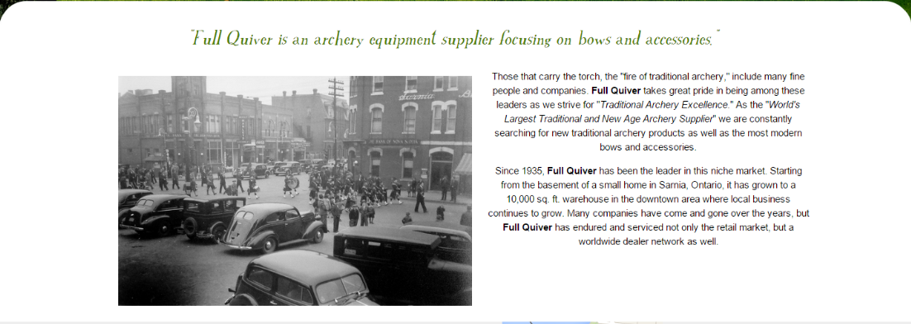About Us Page

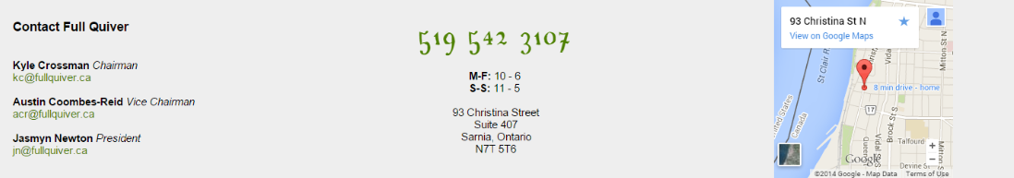On our about us page, you will find information regarding **Full Quiver**. This page is where you will find our history and our mission in selling archery supplies.

We also have the contact information of **Full Quiver**. Here on the about us page you will find the contact information of our core staff. We offer our store information on this page also, for example our phone number, our store hours, and our location. We have a Google map with our store location pinned.